How to Install Software on Windows

Step 1: Open Browser
Follow the instruction shown below:
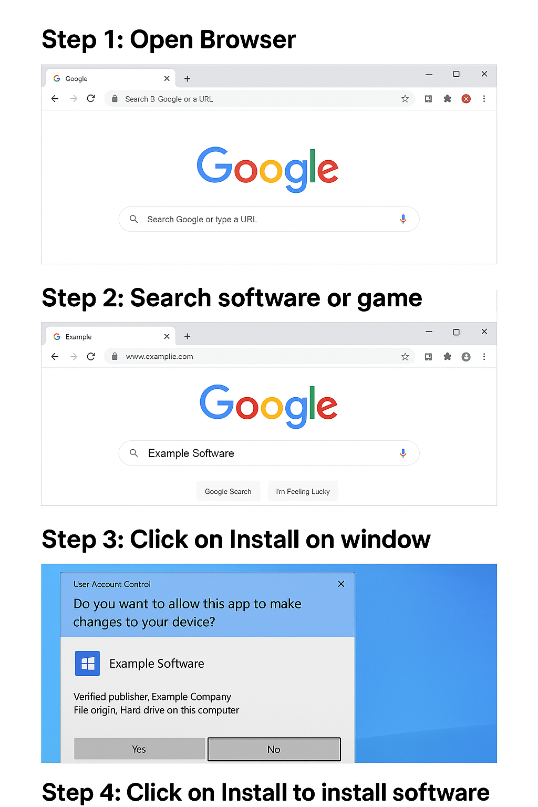

Step 2: Search software or game
Follow the instruction shown below:

Step 3: Click on Install on window
Follow the instruction shown below:

Step 4: Click on Install to install software on system
Follow the instruction shown below:

Installation Complete!
Congratulations! The software has been successfully installed on your Windows system.

