HITEC UNIVERSITY TAXILA CANTT

Abdul Raffay Naqvi
- 013
AICT
Lab Report:2
Submitted To: Sir Muhammad Adnan

Different Types Of Motherboard Ports And Their Functions Explained
The below figure shows the connector side of the Motherboard:
1. HDMI Connector (High-Definition Multimedia Interface)
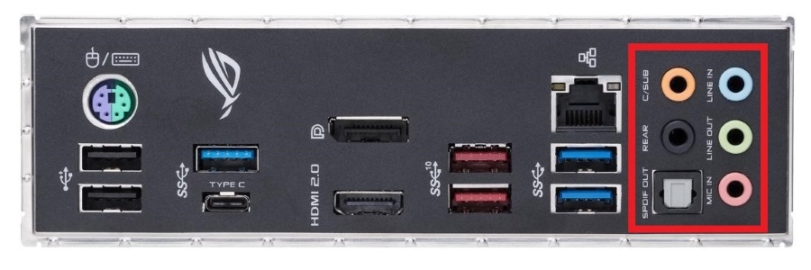
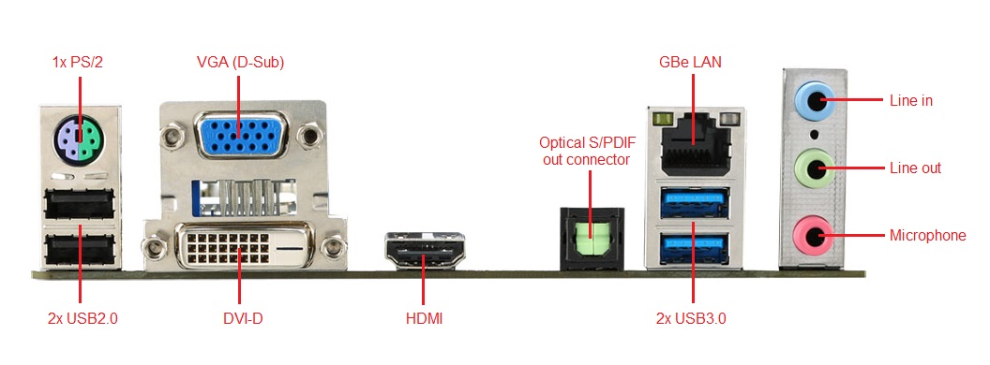
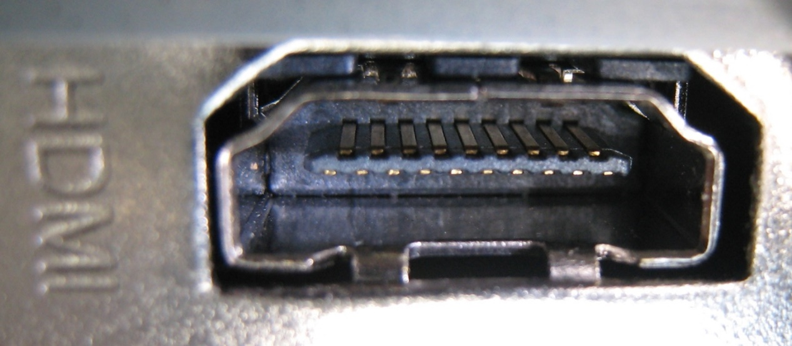

Explanation:
The HDMI port is a fully digital audio + video interface that allows you to transmit both high-definition video and multichannel audio over a single cable. It’s ubiquitous for connecting PCs to monitors, TVs, projectors, and game consoles. Because it is digital, it offers far better signal integrity than older analog ports. Supports high resolutions (1080p, 4K, etc) and is common on modern motherboards and graphic cards.

2. USB (Universal Serial Bus) 2.0 Ports

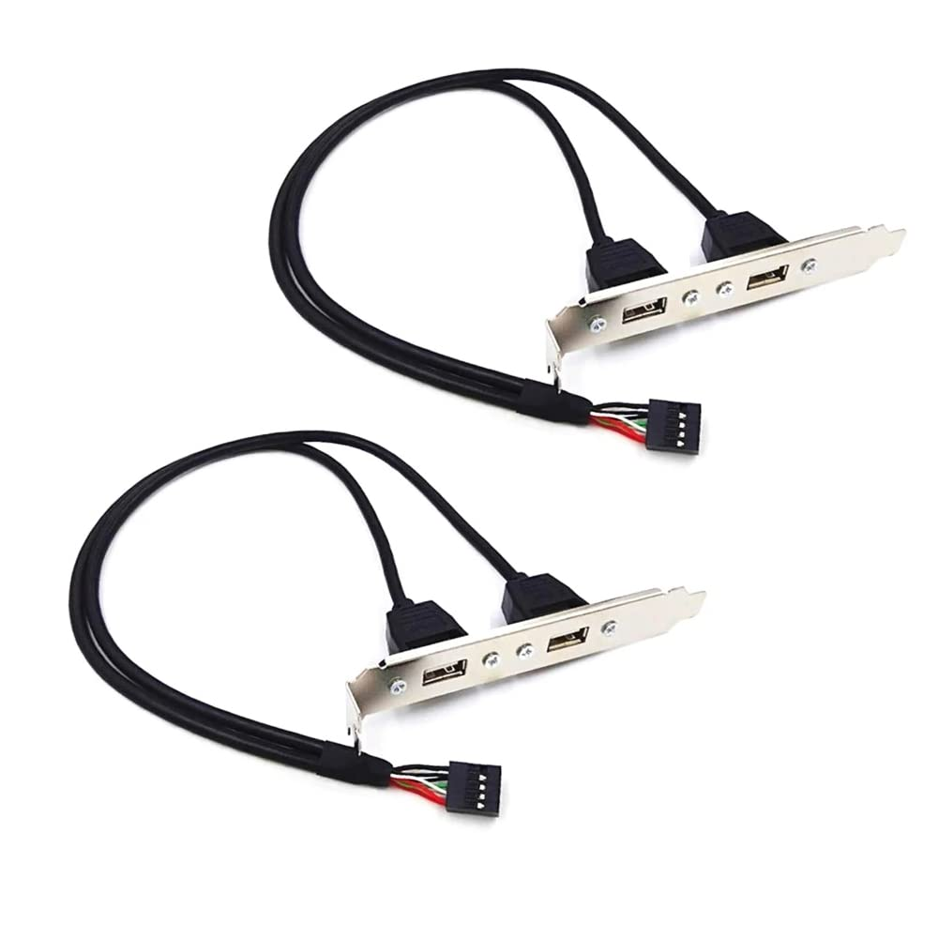
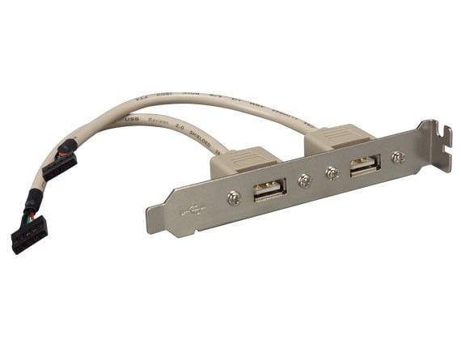
6
Explanation:
USB 2.0 ports are extremely common on motherboards for connecting a wide range of devices: flash drives, external hard drives, MP3 players/iPods, keyboards, mice, cameras, etc. They offer up to 480 Mbps data transfer, are hot-swappable, and supply power to connected devices. While newer USB versions exist, USB 2.0 remains very widespread for general purpose peripherals.

3. RJ-45 (Registered Jack 45) LAN Port
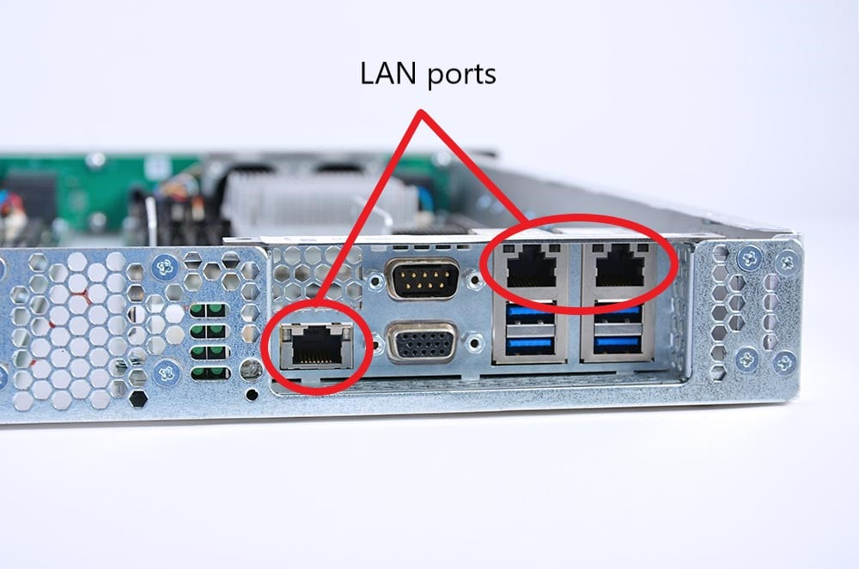
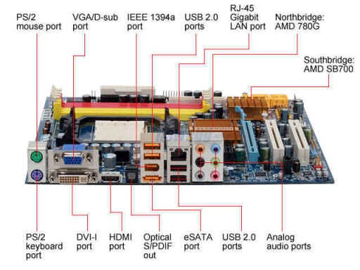
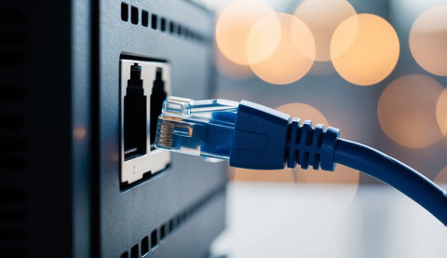

Explanation:
The RJ-45 LAN port enables a wired network connection to a Local Area Network (LAN) using an 8P8C modular connector (commonly called “Ethernet”). This is key for stable and high-speed network access (often 1 Gbps or more) and is typically found on the rear I/O of a PC motherboard. Wired connections through RJ-45 usually offer lower latency, higher stability and better overall throughput compared to wireless for many uses. tutorialsweb.com+2Lifewire+2

4. DVI (Digital Visual Interface) Connector
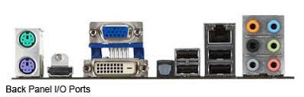
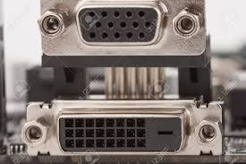
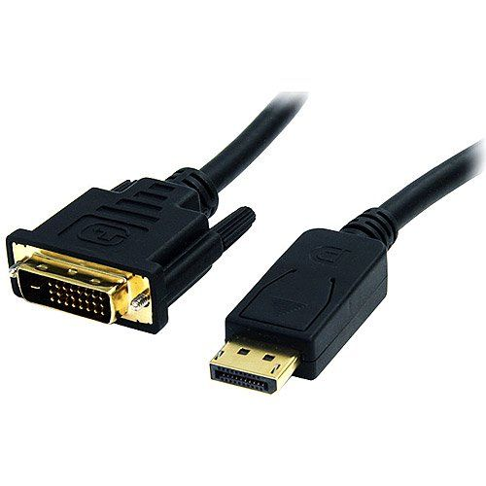

Explanation:
The DVI connector is a digital video interface used to connect a PC to a flat-panel LCD monitor or other digital display. Unlike VGA (analog), DVI carries a digital signal and thus tends to produce a sharper image and less susceptibility to interference. There are different types (DVI-D for digital only, DVI-I supports analog+digital) but the standard rear port on many motherboards is DVI-D.

5. eSATA (External Serial Advanced Technology Attachment) Port
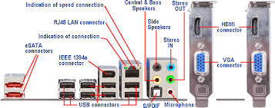
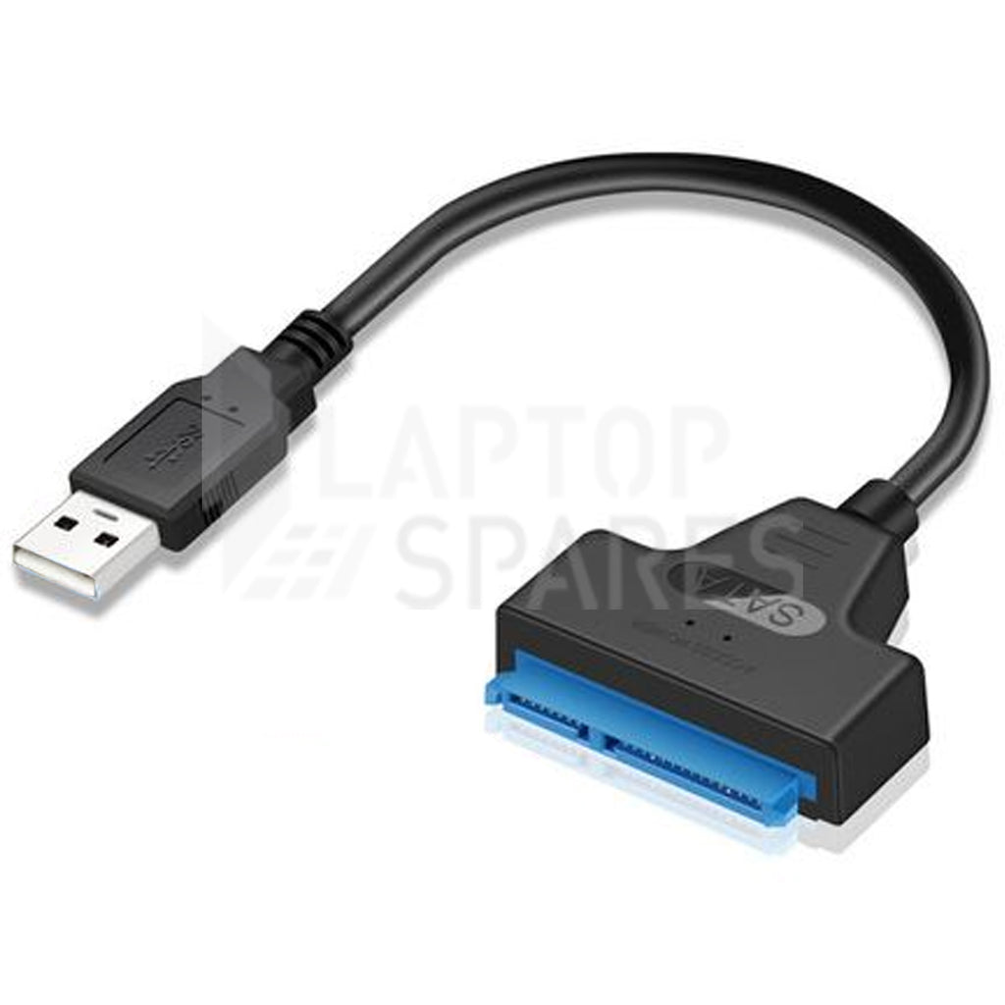
Explanation:
The eSATA port is an external interface for connecting external SATA hard drives and SSDs to a computer with performance comparable to internal SATA. It competes with older interfaces like FireWire or USB 2 in speed and supports hot-pluggable external drives. Some newer motherboards include eSATA in their rear I/O or as combo ports (eSATA/USB). Wikipedia+1

6. Optical S/PDIF (Sony/Philips Digital Interface)
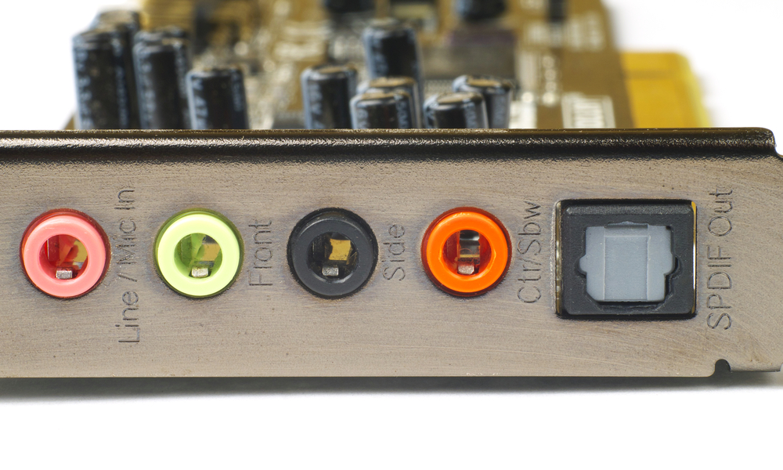
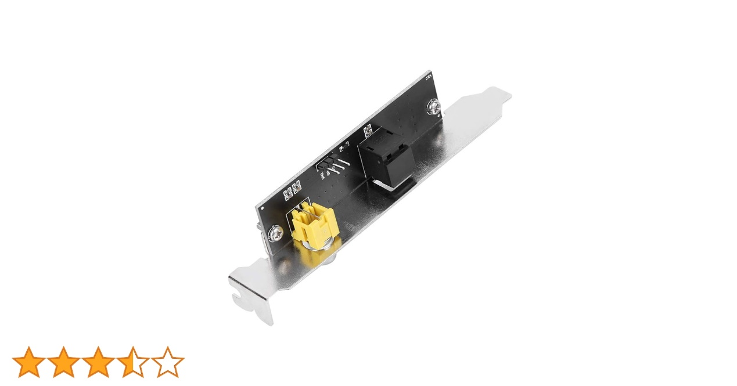
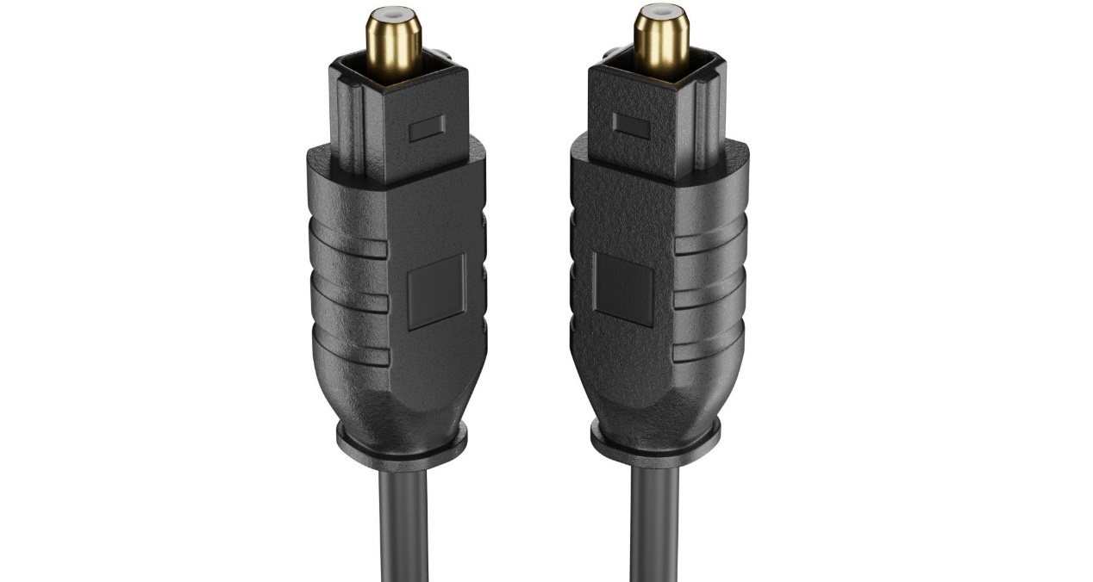

Explanation:
The optical S/PDIF port uses light pulses (via a Toslink connector) to transmit digital audio to home-theatre receivers, powered speakers, or soundbars. Because it’s optical, it’s immune to electromagnetic interference and can carry multi-channel digital audio (such as for surround sound). It’s often found on motherboards aimed at multimedia or HTPC setups. Micro Center+1

7. VGA Port (Video Graphics Array)
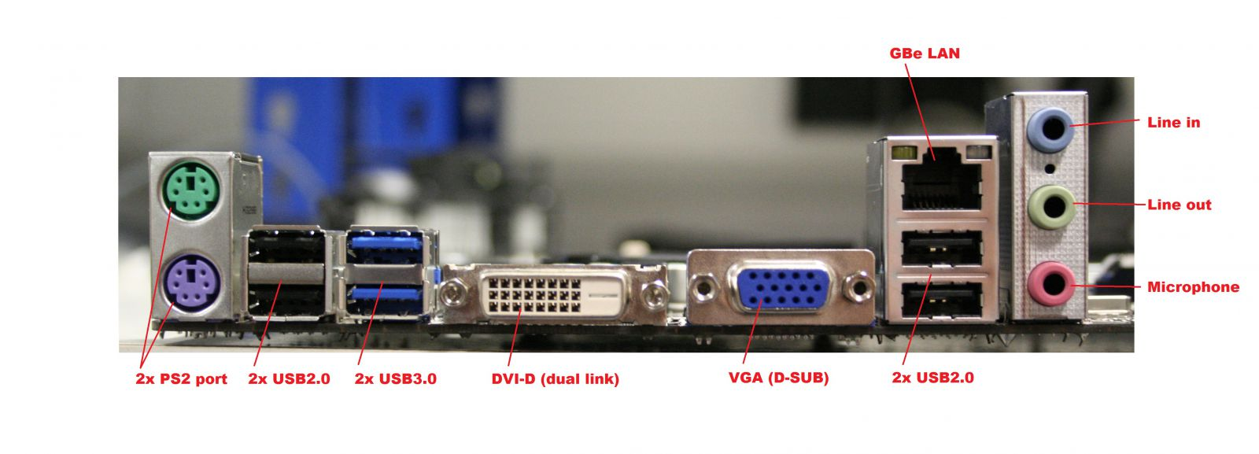
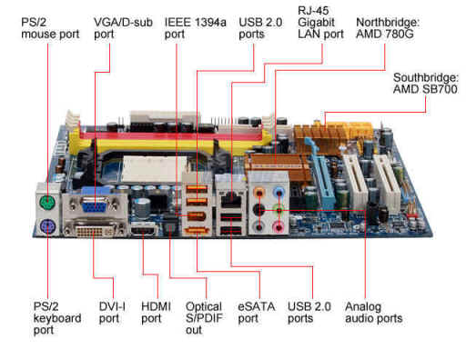
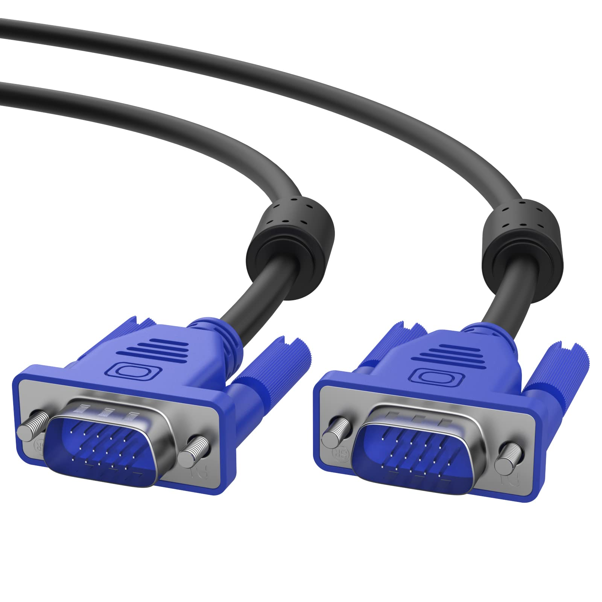

Explanation:
The VGA port is an older interface that carries an analog video signal rather than digital. While it’s legacy and less preferable at high resolutions (because signal quality depends a lot on cable length and quality and can degrade), it is still present on many motherboards to support older monitors or legacy equipment. Good to have for compatibility, but if you want crisp digital image, prefer HDMI/DVI/DisplayPort.

8. PS/2 Keyboard Port (purple)
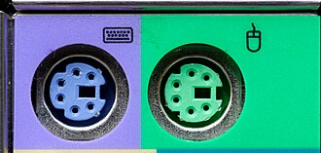
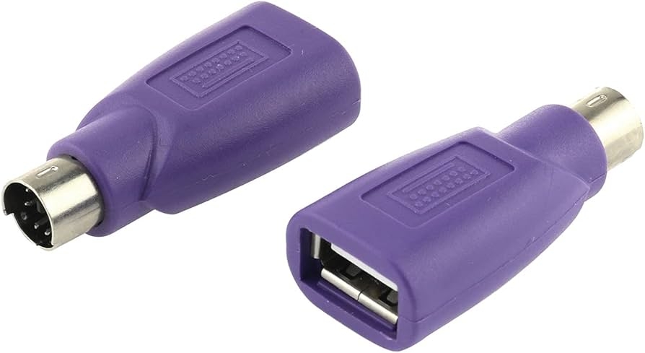
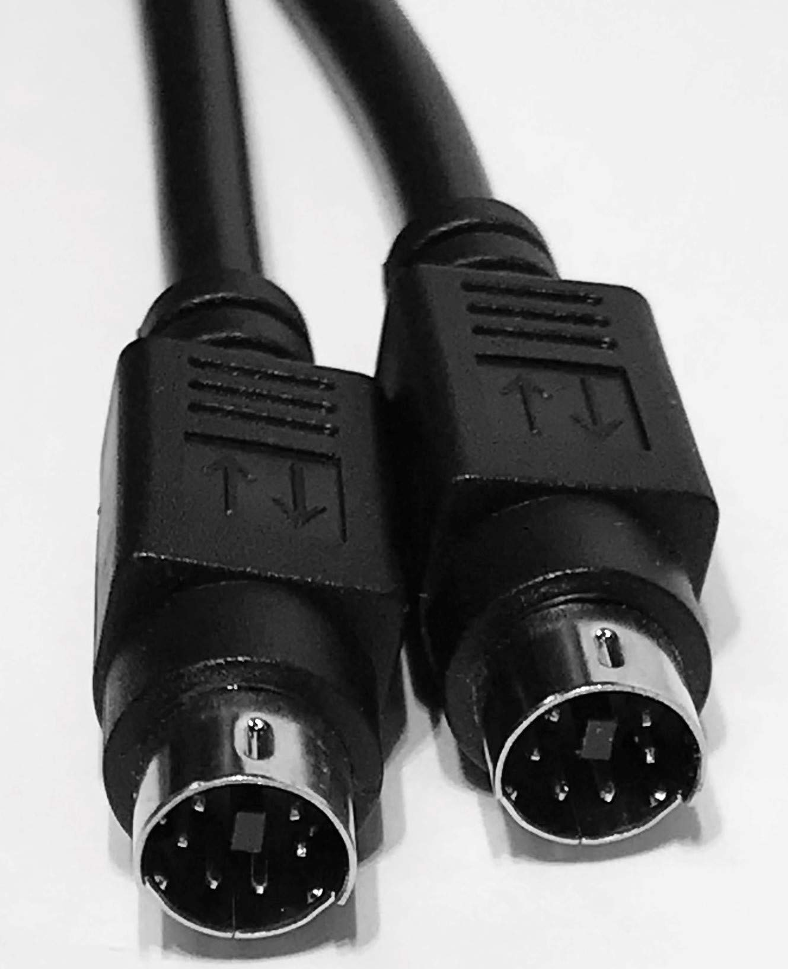

Explanation:
The PS/2 keyboard port (typically coloured purple) is a legacy 6-pin Mini-DIN connector for connecting a traditional keyboard. While USB keyboards dominate today, PS/2 still offers advantages in certain cases (for instance, full-key rollover in some setups) and is sometimes found on motherboards for backward compatibility. Wikipedia

9. PS/2 Mouse Port (green)
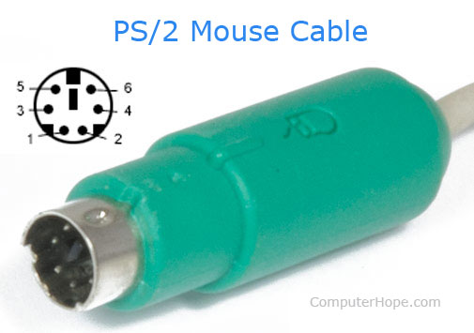
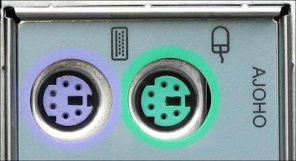
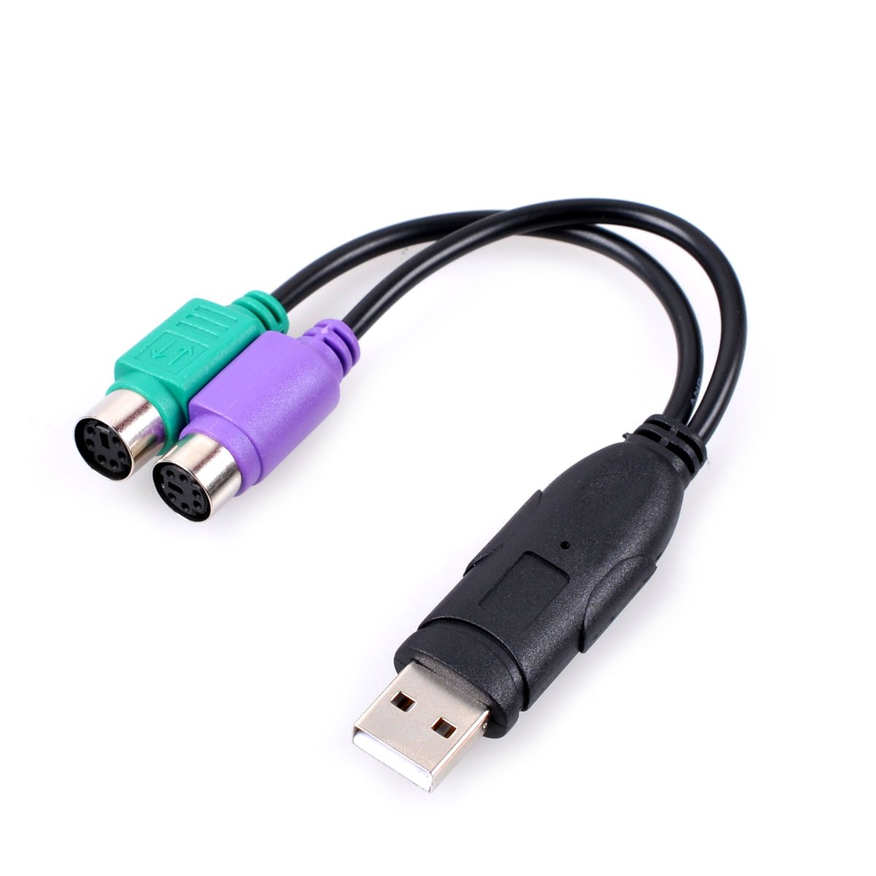

Explanation:
Similar to the PS/2 keyboard port, the green-coloured PS/2 port is for connecting a PS/2-type mouse. While modern mice almost always use USB, PS/2 mouse ports still exist on many motherboards for legacy support or in systems where low-level interrupt handling is desired (e.g., for certain high-performance mice).

10. FireWire / IEEE 1394a Port
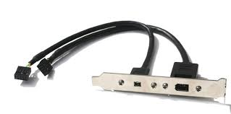
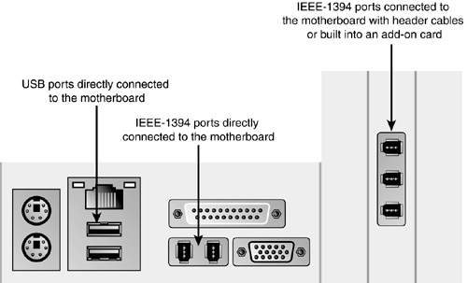
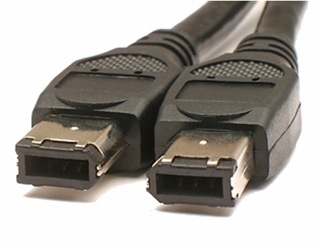

Explanation:
The IEEE 1394a (FireWire 400) port was widely used for high-speed peripheral connections (e.g., camcorders, audio hardware). Though largely supplanted by USB and Thunderbolt, some professional audio rigs and older equipment still use FireWire; thus, some motherboards include it (though increasingly rare). Good to mention for completeness/legacy connectivity.

11. Analog Audio Port (3.5 mm audio jacks)
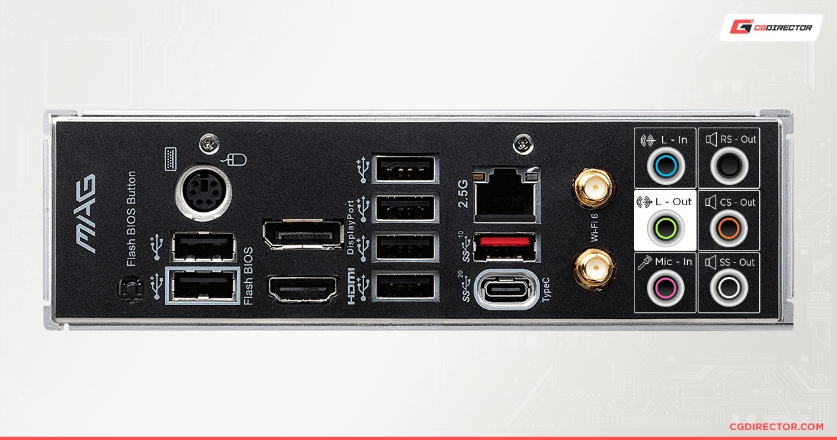
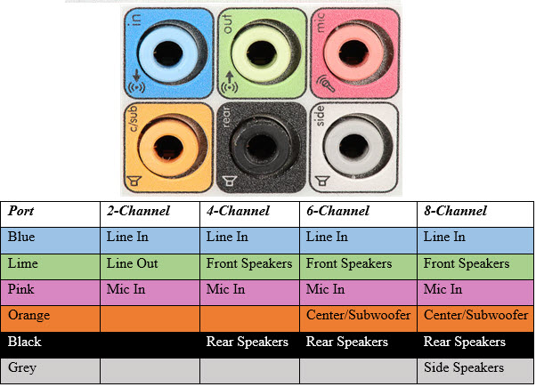
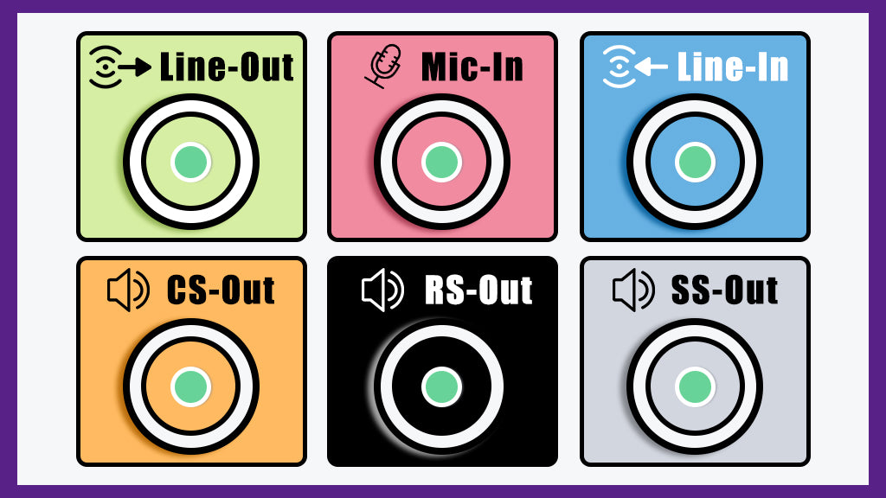

Explanation:
The analog audio ports are the standard 3.5 mm jacks (often colour-coded: green for line-out/headphones, pink for mic, blue for line-in, etc) on a motherboard’s rear panel. These allow connection to external speakers, microphones, headphones, etc. Most modern motherboards also include digital audio outputs, but the analog jacks remain ubiquitous for general audio connectivity.

